BDD Cucumber

Pre-test - <https://www.surveymonkey.com/r/TWSGF3V> (check chat window)

Pre-requisite – Java, Selenium WebDriver

Github Repo:-

Framework - <https://github.com/balaji-githubstore/cucumber-framework-cgi3.git>

BDD – Behaviour Driven Development

Framework

* Cucumber – BDD
* Page Object Model
* Junit/TestNG
* Extent Reports/Cucumber reports

BDD – Behaviour Driven Development – Product development Concept

* Actual BDD - Understanding the requirement
* Modified form of BDD (ATDD) - acceptance testing

Scenario: Login

**Given** – Prequisite

**When** – operation/action

**Then** - verification

Scenario: Login

**Given**: I install the app and I launch the application

**When** I enter phone number

**And** I enter OTP

**And** I click on login

**Then** I should be able to access the gotowebinar portal

Benefits:-

1. Living Documentation
2. Better communications between developer, testers and stakeholders
3. New Member joins
4. Non-techincal

Where to apply BDD?

1. Everyone knows about the product
2. Some of the team members know about the product
3. Only Top level Management knows about the product
4. Someone/somewhere already delivered this prodcut and this is new to your organization
5. Need to R&D and then develop the product

ATDD – Acceptance Test Driven Development

Scenario: Valid Credential

**Given**: I install the app and I launch the application

**When** I enter phone number

**And** I enter OTP

**And** I click on login

**Then** I should be able to access the gotowebinar portal

Scenario: Invalid Credential

**Given**: I install the app and I launch the application

**When** I enter phone number

**And** I enter OTP

**And** I click on login

**Then** I should get error message as ‘Invalid Credentials’

Acceptance Testing:-

1. Code Style – towards techincal (development team)
2. Imperative Style – Falls between techincal and non-techical team
3. Declarative Style – non-techincal team – stakeholders

Code Style:-

Scenario: Valid Credential

Given: I open browser ‘chrome’ and I navigate to gotowebinar page

When I enter phone number as ‘9988989’ at id as ‘user_email’

And I enter OTP as ‘78788’ at name as ‘user[email]’

And I click on login

Then I should be able to access the gotowebinar portal

Imperative Style:-

Scenario: Valid Credential

Given: I have browser with gotowebinar page

When I enter phone number as ‘9988989’

And I enter OTP as ‘78788’

And I click on login

Then I should be able to access the gotowebinar portal

Declarative Style:-

Scenario: Valid Credential

Given: I have browser with gotowebinar page

When I enter valid credentials

Then I should be able to access the gotowebinar portal

Installation:-

1. JDK 8 and above - <https://www.oracle.com/in/java/technologies/javase/javase8-archive-downloads.html>
2. Eclipse IDE - <https://www.eclipse.org/downloads/download.php?file=/technology/epp/downloads/release/2022-06/R/eclipse-java-2022-06-R-win32-x86_64.zip>
3. Cucumber plugin for Eclipse –

Eclipse 🡪 Help🡪 Eclipse Market place 🡪 install cucumber eclipse plugin

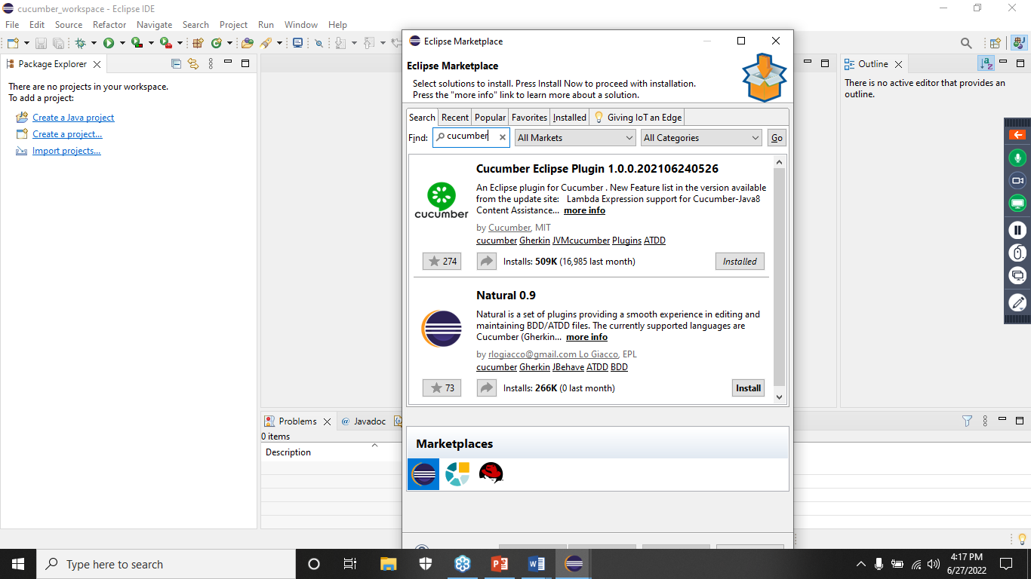

Architecture of Cucumber – BDD

Feature file (.feature) 🡪 Step Definitions (.java)

Steps to create BDD Framework in java

1. Create or Open Workspace
2. Make sure Cucumber Eclipse plugin is installed
3. Create Maven Project – mention group id and artifact id

Maven – Build Management Tool

* POM.xml – Project Object Model – control the entire project
* Helps to setup the complier enviornment
* Helps to download and configure the jars automatically (using dependencies – download dependent jars as well) required for the projects
* Migrate the project to different environment easily
* From scratch to deployment – everything will be taken care by maven

1. Add the jar (dependencies) related to automation – cucumber and selenium
   1. Cucumber -

Cucumber-java - <https://mvnrepository.com/artifact/io.cucumber/cucumber-java/7.4.1>

Cucumber-junit - <https://mvnrepository.com/artifact/io.cucumber/cucumber-junit/7.4.1>

* 1. Selenium - <https://mvnrepository.com/artifact/org.seleniumhq.selenium/selenium-java/4.3.0>

1. Do force update of Maven Project if any issues

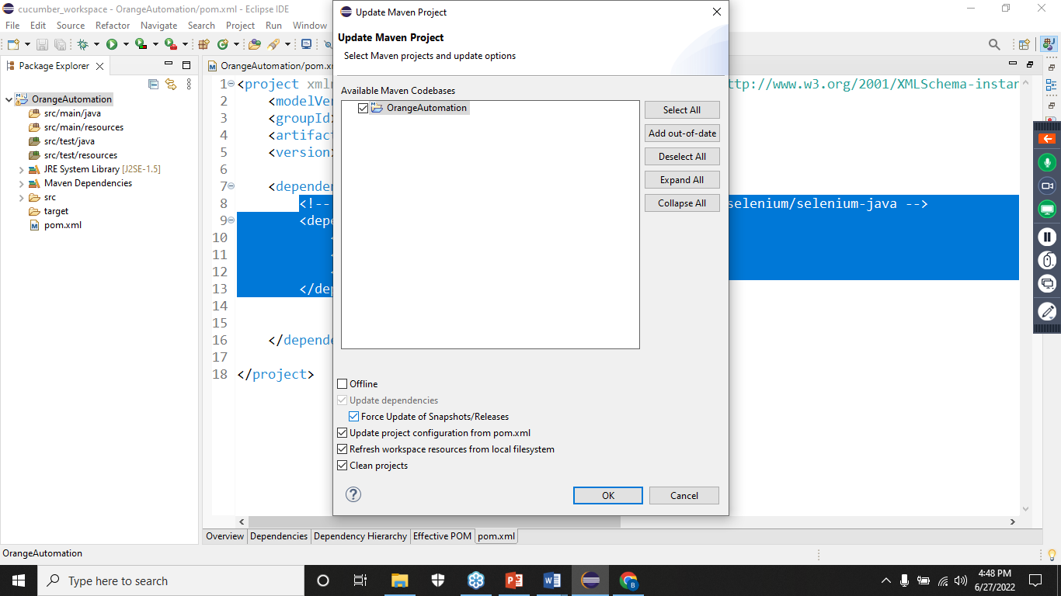

1. Git - Git is a free and open source distributed version control system.

Architecture:-

Project (Local system) 🡪 Local Repository (local system) 🡪 remote repository (github, aws code commit, gitlab, bitbucket)

1. Create Feature file (.feature)
2. Create feature header
3. Create Feature Description
   1. Unformatted description

I need to login to portal for manging the employee details

* 1. Formatted description

**In order to [Business goal]**

**As a [Role]**

**I want to [visible change in the application]**

1. Create scenario and provide scenario title
2. Create given, when, then
3. Create runner file and trigger feature to generate step defn
4. Connect feature and step defn using runner file.
5. Monochrome – to remove unwanted symbols, text in the console
6. Publish = true 🡪 publish the report in internet
7. For Selenium automation – WebDriverManager dependencies for download and configure the drivers based on platform, browser, browser version

<https://mvnrepository.com/artifact/io.github.bonigarcia/webdrivermanager/5.2.1>

1. Step Parameterization – helps to reduce duplicates in the step definitions.
2. Sceanrio Outline –
   1. hepls to remove duplicates in feature file.
   2. Run one sceanrio with different set of test data

Reference:

BDD – To improve readability and maintenance

1. Step Parameterization – Code reuse
2. Scenario Outline – one scenario - multiple set of test data
3. Background
4. DataTable

Selenium WebDriver - <https://www.selenium.dev/>

1. Add dependencies – selenium, webdrivermanger
2. Launch browser
3. Inspect – tagname, attribute , text or not
4. Locators –
   1. Id
   2. Name
   3. Classname
   4. Tagname
   5. Linktext
   6. partial link text
   7. xpath
   8. css

bala,bala123, Invalid credentials

peter,peter123, Invalid credentials

mark,mark123

Scenario: Invalid Credential1

Given I have browser with orangehrm application

When I enter username as 'bala'

And I enter password as 'bala123'

And I click on login

Then I should get the error message as 'Invalid credentials'